Introduction
The Canadian economic structure and framework have gained more relevance following the nature of infrastructure whereby different models are used in its transportation system. There are five models of transport in use in Canada, and they include: are Motor carriers, Railroads, airlines, Water carriers, and pipelines. This paper is addressing each of the models and associated benefits as well as limitations.
Canadian Airlines
Airline model of transport is where passengers and cargo are transported through the air using aircraft or airplanes. In Canada, airlines serve a very critical role in the overall transportation mix. Different airlines carry cargo and passengers locally within regions, nationally and internationally. According to Air Transportation-Transport Canada (2020), 1889 aerodromes are dependent on Canada’s air sector with at least 26 airports. Most used air carriers in Canada are sky regional and porter airlines that operate as Air Canada express. It is worth noting that, in terms of passenger volume, Canada has the largest with the world's 15th largest passenger airline. Back in 2011, the workforce in Canadian airlines stood at 23, 700 employees that transported cargo and passengers to around 181 destinations globally. Currently, Canadian airlines are having over 205 mainline fleets of aircraft, with 157 of them that flies under air Canada express. The network of the airline in Canada is enhanced by five regional airlines. These include Central mountain air, Jazz Air, Exploits Valley Air Services Ltd., Sky regional airlines, and air Georgian.
Benefits and limitations
The airline in this state is significant in that it has created employment opportunities for many individuals such as pilots, Air hostess, Engineers, and mechanics. It also the source of revenue to the Government in that the $1.3 total expenses are incurred by Federal airline programs with an estimated revenue of $9 billion (Conboy, 2013). Also, in 2019, $17.2 billion in revenue from passengers was reported. Importantly, it is the world's safest air transport due to a decline in the issues of accidents for the last decades. However, this model of transport has some underlying cons. This includes airport pollution due to noise from aircraft and its components. Emission of pollutants from engines of the plane like Nitrous oxide, sulfur oxide, and carbon (iv) oxide and other volatile compounds affects air quality. Fortunately, there are action plans and voluntary agreements and policies set aside for reducing impacts caused by such emission. The policies support the use of alternative fuels, emission reduction through the regulatory framework, and measuring and mitigating emissions in airports (Air Transportation-Transport Canada, 2020).
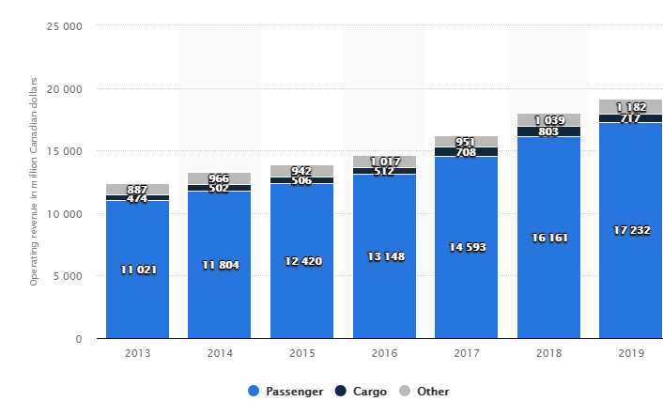
Canada’s pipeline transport system
A pipeline is a model of transport where liquid and gaseous products are transported through pipes. Usually, energy is required in daily lives, and as such, the Pipeline transport system in Canada plays an essential role in delivering different energy forms like crude oil, natural gas, natural liquid, and petroleum products. The pipeline is an essential model of transport in the Canadian economy as it has offered many jobs to the communities and revenue to the Government. It has also contributed to economic prosperity by supporting the export of gases and oil to other nations. The pipeline network in Canada comprises of four systems such as Gathering, Feeder, Transmission, and distribution pipelines. The gathering pipelines are used in moving natural gas and crude oil to processing facilities from wellheads. The feeder pipelines are used in transporting oil products to transmission pipelines from batteries, processing facilities, and natural tanks. The use of transmission pipelines does the transportation of crude oil within international boundaries or provinces. The distribution companies make use of distribution pipelines in delivering natural gases to various places like Homes, industries, and different businesses (NEB, 2020). See the pipeline system overview below:
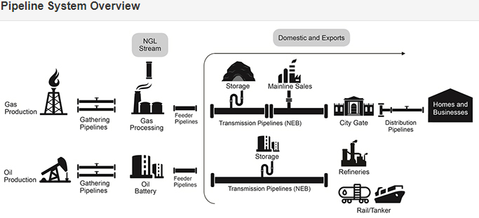
Benefits and limitations
As already mentioned, the pipeline model is advantageous and beneficial to the Canadian economy as they earn revenue to the Government as well as creating jobs for many Canadians. Besides, they are preferred because they are the safest model for transporting natural gas and oil in Canada. They also move natural gases as well as oil in large volumes efficiently. Their development comes with accessibility to international markets that are growing, and this ensures that Canada can get to understand the real value of is oil and natural gases. However, the disadvantages are that significant delays are experienced following legal procedure. Besides, accidental leakages, if undetected earlier, can lead to loss or even cause a fire. Fortunately, such incidents are rare.
Canada’s Motor carriers
In Canada, motor carriers are used widely in most chains of transport. It involves the use of small pickup trucks and motor trucks as well as a combination of large tractor-semitrailer. Mostly, their industry of motor carrier comprises private motor carriers owned by individual firms who lease and operate such trucks. The motor carriers transport general goods, containers, fuels, gas, and sand in a more secure way.
Benefits and limitations
The Canadian motor carriers facilitate a reduction of deaths, crashes, and injuries resulting from buses and large commercial trucks by working closely and adhering with industrial regulations that govern safety in commercial operation. This ensures safety to operators and drivers operating commercial vehicles. According to Motor Carriers, Commercial Vehicles and Drivers - Transport Canada. Tc.gc.ca. (2020) with the existence of national and provincial regulations, motor carriers are secure, and this makes them more useful. However, their usage is limited by the Motor Vehicle Transport Act (MVTA).
MVTA regulations
a). Motor carrier safety fitness and Certificate regulations: This regulation requires that all the motor carriers should provide a certificate for safety fitness to be allowed to operate in Canadian Highways. So, the jurisdiction controls their operation by issuing and removing such documents.
b). Commercial Vehicle Drivers Hours of Service regulations: This regulation requires that, set rules of work hours and rest should be adhered to by motor carriers as well as their drivers.
Railroad transport in Canada
In Canada, railroad transport is a very vital element in the transportation system. It generates over $ 10 billion every year from the transport industry. 95% of this comes from the railroad operations. The 5% revenue comes from commuter passenger rails operating in towns. The dominant railroad operators here are Canadian Pacific Railway and Canadian National Railway. Over 250 million dollars is realized from these freight operators, whereby Canadian National Railway contributes to over 50% and Canadian Pacific Railway accounting to 35%. Collectively, the two accounts for 85% of revenue annually.
The major components of the railroad in Canada are shoreline railways and passenger railways. Shortline Railways are the most critical component of Canadian railroads that feeds and deliver traffic in and out of mainline rails. The passenger railways compress rail operators in intercity, Urban transit as well as heritage railroads serving at least 450 counties within 12500 km rail network. Below is an image of a railroad in Canada.
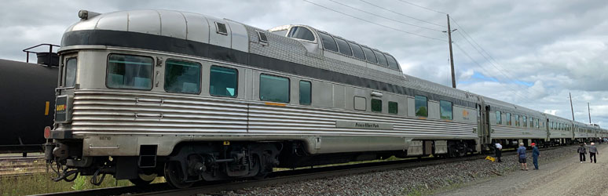
Source: https://www.seat61.com/Canada.htm

Benefits and limitations
The railroad model in Canada is of benefit .it has contributed to the growth and development of both the economy and industry. With the construction of railways in Canada, economic development has improved, opening up more businesses as well as employment creation. Transport has been revolutionized in Canadian regions. Different parts of Canada have been linked by railways, which Toronto in south Ontario being linked with Great western (James, 2015). Industrialization and new markets have opened, creating a demand for iron and fuels. However, the railroads are limited by inadequate funds during construction and maintenance.
Water carriers in Canada
In Canada, water is a mode of transport, and it involves a couple of vessels moving on the water like ferries, ships, and boats. The water transport takes place in the form of inland water transportation with and or without ferries. Besides, deep sea, coastal and great lakes water transportation with and without ferries is used. The aim of water carriers in Canadian transportation is to move passengers and cargo through water carried out in harbors. Below is seaway and water carriers at Soo Locks at Sault Ste Marie-Canada
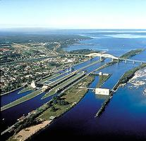
Benefits and limitation of water carriers
The creation of employment stands a key benefit of water carriers’ usage in Canada, whereby; people are offered jobs in Canadian shipbuilders. As a trading nation, water carriers in Canada cannot be underestimated. The water carriers like the ship are used in transportation by covering great distances. It has influenced the free movement of manufactured goods within domestic and international markets hence contributing to the growth and advance of trade and growth and development of the Canadian economy (Karl, 2015). However, the growth, development, and usage of water carriers in Canada can be limited due to the high cost of building water vessels like ships and ferries. Besides, the water carriers serve those areas where there are waterways only.
Conclusion
To summarizes in the Canadian transport system, Motor carriers, Railroads, airlines, Water carriers, and pipelines are the most common models of transport used in the transportation of both cargo and passengers from point to another. All these models play a very critical role in the Canadian economy. These models support development and advancement in trade and industrialization. Besides, all the models of transport contribute to the creation of employment in different areas. People are employed as drivers, engineers, pilots, mechanics, and captains. However, development and usage may be limited due to the high cost of constructing the unit of carriage as it requires substantial investment. Some models are limited to areas served with water only. Furthermore, other models like railroads cannot be used where there are no rails.

References
Air Transportation-Transport Canada. (2020). Retrieved 23 April 2020, from https://www.tc.gc.ca/eng/policy/anre-menu-3018.htm
Conboy. A. (A2013). Air Transport Industry. https://www.thecanadianencyclopedia.ca/en/article/air-transport-industry
Mazarine. E. (2020). Air Canada -operating revenue 2013-2019. https://www.statista.com/statistics/542775/operating-revenue-of-air-canada/
NEB (2020. Canada’s Pipeline Transportation System 2016 - Canada's Pipeline Transportation System. Cer-rec.gc.ca. (2020). Retrieved 23 April 2020, from https://www.cer-rec.gc.ca/nrg/ntgrtd/trnsprttn/2016/cnds-ppln-trnsprttn-systm-eng.html.
https://www.iiste.org/Journals/index.php/CER/article/view/48663. (2019). https://doi.org/10.7176/ceis/11-6-06
Motor Carriers, Commercial Vehicles, and Drivers - Transport Canada. Tc.gc.ca. (2020). Retrieved 23 April 2020, from https://www.tc.gc.ca/eng/motorvehiclesafety/roadsafety-motor-carriers-commercial-vehicles-drivers-1312.htm.
James H. Marsh. (2015). Railway History. https://www.thecanadianencyclopedia.ca/en/article/railway-history
Karl M. Ruppenthal. (2015). Transportation. https://www.thecanadianencyclopedia.ca/en/article/transportation

